


Source Code Lab

Name: Kanam Harshith Reddy

Branch: B.Tech

Section: CSE

SEN: A86605223046

Submitted To: Dr. Monit Kapoor

Date of Submission: 6 June 2025



Amity School of
Engineering & Technology

INDEX

SI | Topic | Date | Pg No
1 | Git & GitHub Fundamentals- Install Git & GitHub- Basic Linux Commands | 31-01-2025
2 | Committing & Viewing History- Understanding Commits- Viewing Git Logs | 14-02-2025
3 | Branching & Version Comparison- Creating & Managing Branches- Using git diff | 07-03-2025
4 | Remote Repositories- Pushing Local Repos to GitHub | 16-05-2025
5 | Collaboration & Conflict Resolution- Inducing & Resolving Conflicts- Opening & Closing Pull Requests | 21-05-2025

- Git & GitHub Fundamentals

- Basic Linux Commands
- ls – List directory contents
- ls -ah – List all files including hidden ones
- pwd – Print working directory
- cd .. – Move to the parent directory
- mkdir – Create a new directory
- cd <folder> – Change into a directory
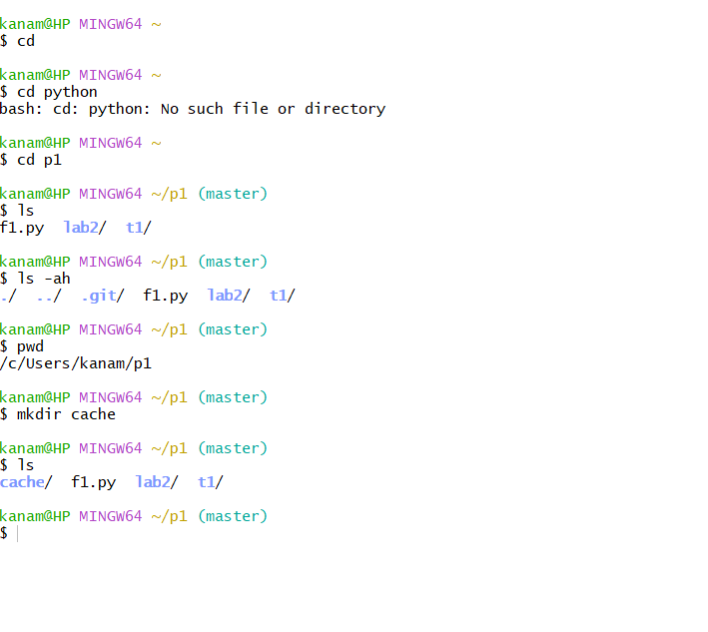

- File Operations
- vi <filename> – Open file in vi editor
  - Press i to insert
  - Press Esc to exit insert mode
  - Use :wq to save and quit
- cat <filename> – Display contents of a file
- ls -l – Show file permissions and details
- history – Show command history
- clear – Clear the terminal screen
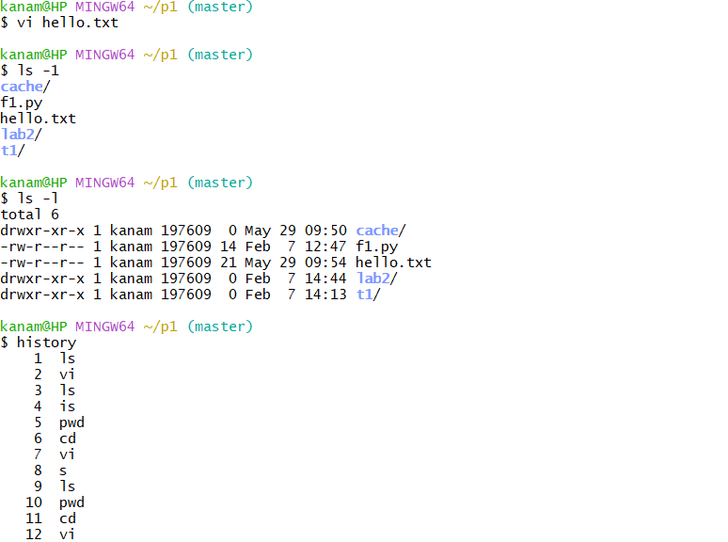


- Git Initialization
- git init – Initialize a Git repository
- git status – Show the working tree status
- git add <filename> – Stage a file for commit
- git commit -m "message" – Commit changes with a message
- Configure Git with your email and username

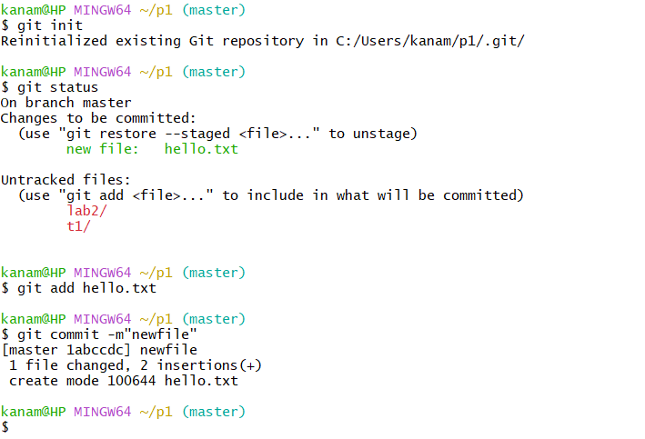

- Committing & Viewing History

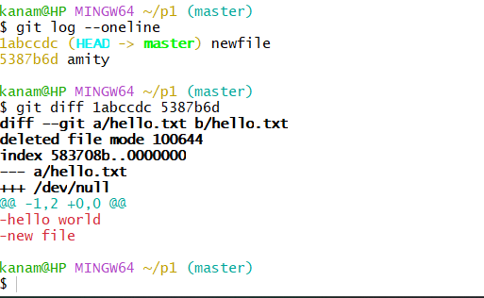

- Branching & Version Comparison
1. Branching:
* git branch [branchname]: Create a new branch
* git checkout [branchname]: Switch to a different branch
* git checkout master: Switch back to the master branch
* Concept: Any branch and the master branch can have completely different codebases after many commits in their respective branches.
* HEAD: A special pointer that points to the last commit in the current branch.
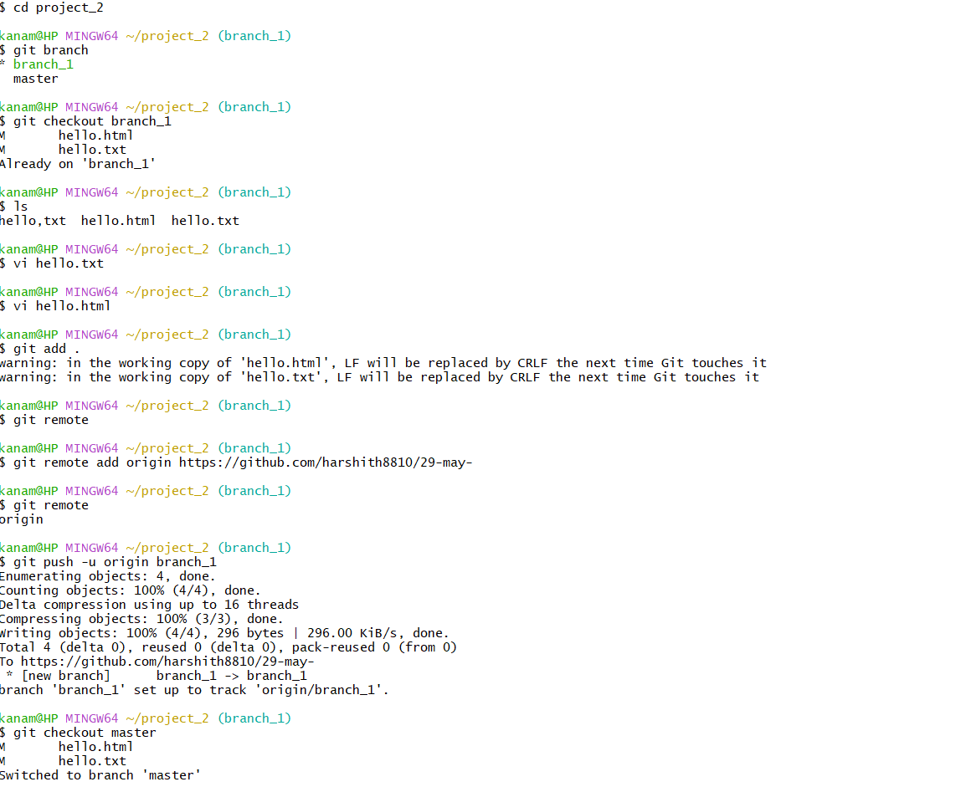

2. Comparing Changes:
* git diff: Show changes between commits, commit and working tree, etc. 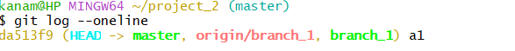

- Push Local Repository to GitHub (Remote)
Linking Local to Remote Repository:
* git remote: Helps connect your local repository to a remote repository
* git remote add origin "[address of repo GitHub]": Add a new remote repository (e.g., github.com/kavya4kavya/Repo_1). origin is a common variable name but can be anything.
* git push -u origin master: Push local master branch to the origin remote. The -u flag sets the upstream. This is used when there's only one branch.
* git push -u origin [branchname]: Push a specific local branch to the remote.

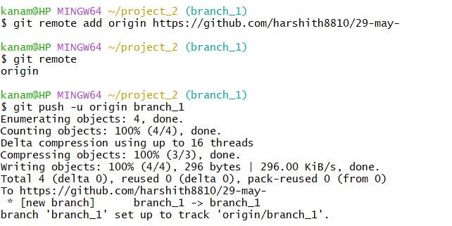

- Induce Conflicts, Open and Close Pull Requests

  - Git Merging & Conflicts:
* git merge: Integrate changes from one branch into another.
* Conflicts arise during merging when Git cannot automatically reconcile diverging changes.
* Use a merge tool to resolve conflicts.
* git mergetool: Command to launch the configured merge tool.
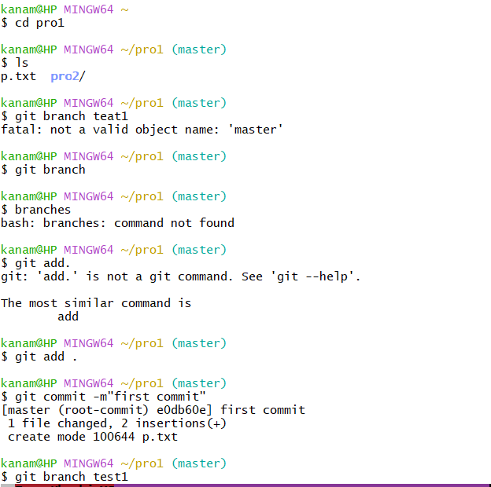


2. Gitignore: *. gitignore file: Specifies intentionally untracked files that Git should ignore.
* Files listed in .gitignore will not be tracked by Git and will not be mirrored on GitHub.

3. Pull Requests: * Opening a pull request
